ODOT Electronic C92 Process

Overview
Beginning with the July 15, 2010 letting, the Department will accept Requests to Sublet (C92) electronically. This program is called SiteXchange and is created by the same makers of Expedite, the program ODOT uses for electronic bidding. SiteXchange will benefit both contractors and ODOT due to mathematical checking and fewer keystrokes.

Download the Software
Like Expedite for bidding, SiteXchange must be installed for this process. Go to ftp://ftp.dot.state.oh.us/pub/contracts/SiteXchange/setup.exe to download the software. Run the program to install SiteXchange on your computer.

Timeline
Again, like Expedite, ODOT provides data files for each project. After ODOT awards the projects, the SiteXchange file will be created and provided for the prime contractor. The prime fills out the file with the subcontractor names and amounts and returns the file to ODOT. Once approved, ODOT will notify the contractor of the approval. There must be only one file for all subcontractors. As subs are added throughout the duration of the project, add them to the current file and resubmit – do not submit a new file with only that subs information.

Goal Amounts
For subcontracts for goal, the C92 may be submitted using SiteXchange but the the goal amounts must still be submitted using the existing Subcontract Agreement process.

Populating the Data
Of course, a C92 provides a subcontractor name, the item to be performed and a dollar amount for the item.

To add a subcontractor, right-click on the word Subcontractors, as in the picture below. (Likewise, right -click on a subcontractors name to add sub-subcontractors.)

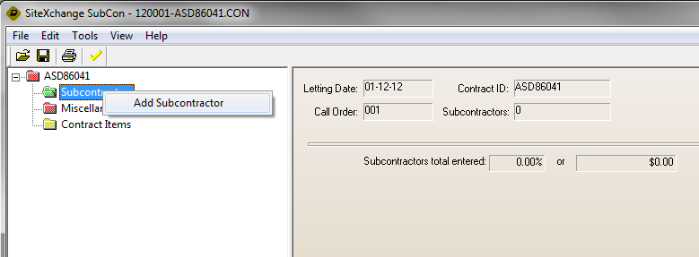

Select a Name, Work Type, Sub Type and DBE Type on the right hand side (top picture). When all three items are selected, the contractor name will appear on the left and the folder color will change to green (bottom picture).
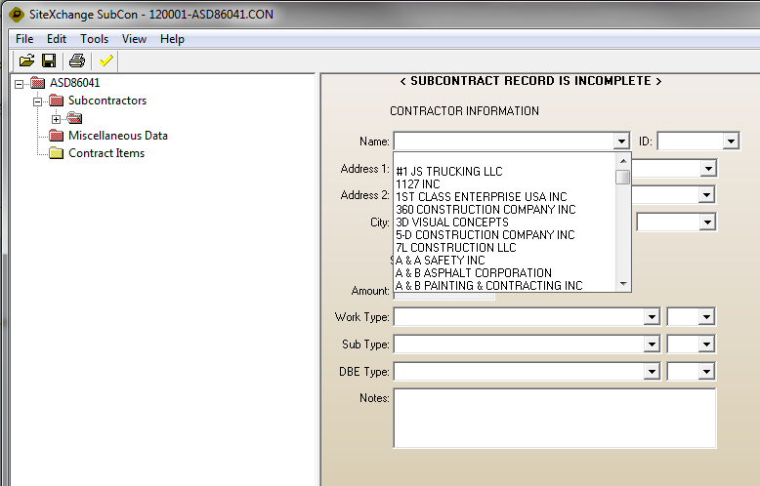

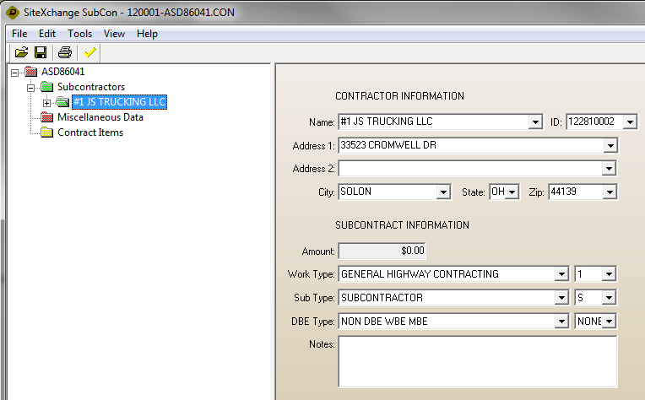

That leaves the items to be subbed. Click on the + next to the contractor name on the left side and then click on Subcontractor Items to show all items on the right.

Click the checkbox next to the item to be subbed and the Quantity, Unit Price and Total boxes will be populated. For partially subbed items, edit Quantity and Unit Price and they will automatically calculate and update the Total. Please do not edit the Total. Repeat the process for every subbed item.

